**Task Description:**

Set up a VPC with an Internet gateway, create a public subnet with 256 IP addresses, a private subnet with 256 IP addresses, make a route table connecting the Internet gateway and the subnets, and launch a Linux EC2 instance by using the above VPC and public subnet.

VPC created: CIDR 256 ip address:

My CIDR range: 172.86.8.0/24  
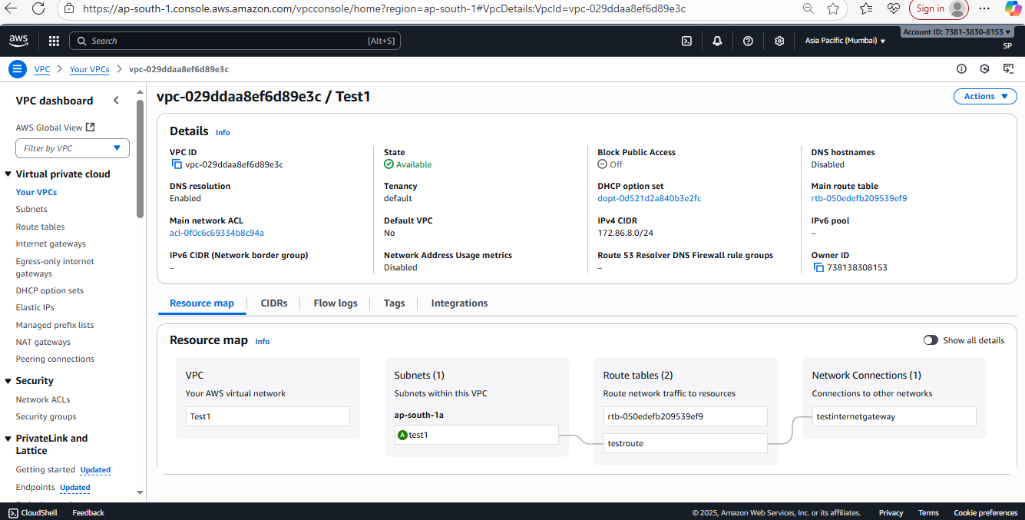

Subnet created:  
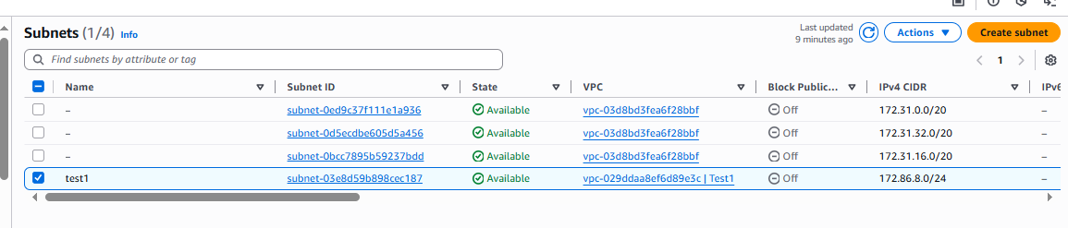

Route table created and associated with subnet:  
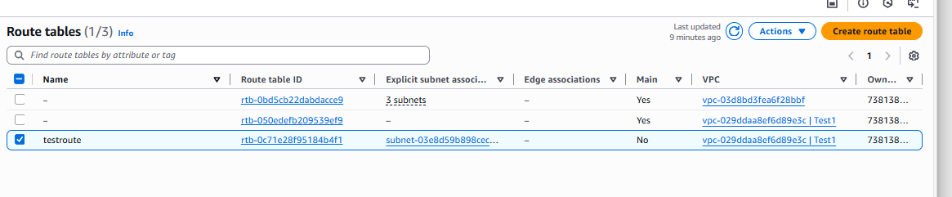

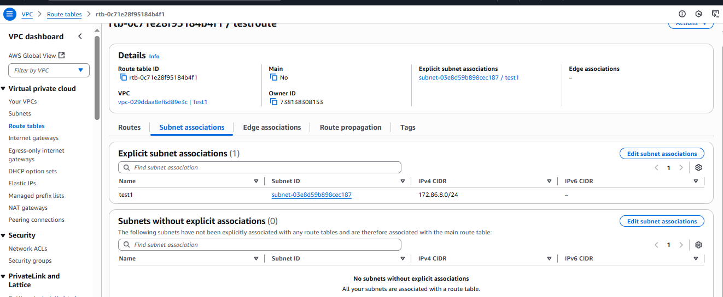

Attached with internet gateway which created newly :

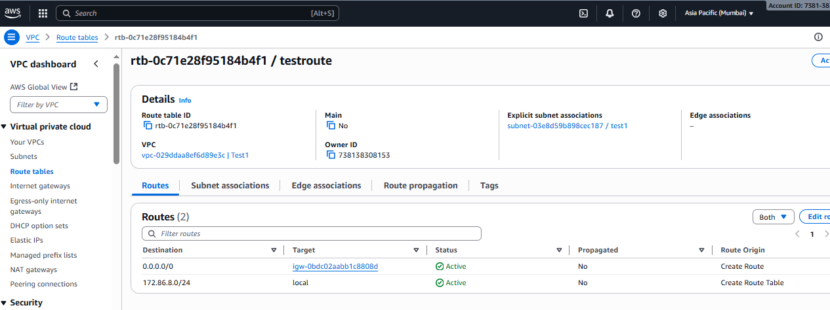

Internet gatway created and attached with VPC:

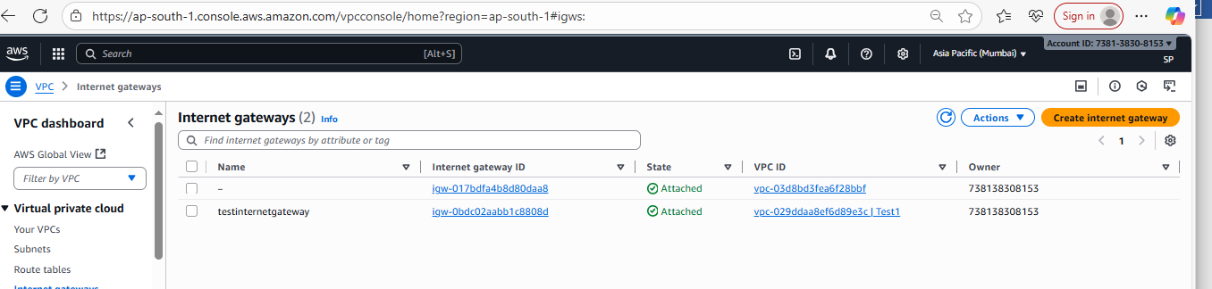

Lanunched instance with new 256 public subnet:  
